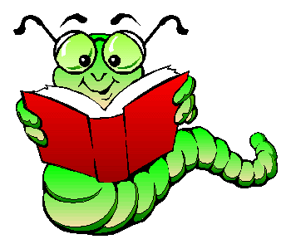 What is active reading?
- Active reading is involved reading. While passive readers read words, active readers read ideas. A passive reader's goal is to get finished. An active reader's goal is to learn something.

- When you read books and magazines for pleasure, you are being a passive reader. This is nothing wrong with this because the goal is enjoyment, not learning.

- Active reading is reading with a determination to understand the relevance of the material.
What are some common active reading strategies? 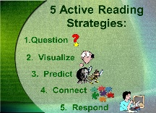
1. Read out loud. It is easy to daydream when reading silently, but reading aloud requires you to be fully engaged. It also helps because you are both seeing and hearing the information!
2. Ask questions of the text. Who wrote it? When? Who was the intended audience? Does it link with any other texts you’ve read? What about the text is unclear to you?

3. Underline or highlight important words or phrases. This will help you to easily see which points were important when you need to return to them.
* While reading, ask yourself what I would ask you on a test!

4. Make annotations in the margins to summarize, raise questions, jot down examples, or challenge what you have read. (Use sticky notes if you don’t want to write in your book! I’ve even seen students color code their sticky note notes!)

5. Test yourself by reading for a set amount of time (20 minutes maybe). Then put the book down and jot down the important points you remember before going back to fill in the blanks.
* When I come across an important event in a chapter, I go back to the title page of that chapter and begin write it down. By the end of the chapter, I’ve made a list of everything that happened in that chapter on its title page. This is a great way to both summarize the chapter and to find details later on! This is called “clarifying.”
* Another way to test yourself is to explain what you have read to someone else.
6. Visualize what is being described. (Looking up pictures helps!)

7. Make personal connections.
8. Make predictions. This is especially important if the author uses a lot of foreshadowing!

